HOW THE GOSPEL
CAME TO BRITAIN
W. L. EMMERSON
Source:
Present Truth, Jan. 7 to April 28, 1932

Cover:
Saint Columba
Armagh St. Patrick’s Cathedral of the Church of Ireland
Photographer: Andreas F. Borchert
wikimedia

Fonts:
Liberation Sans Narrow
Linux Biolinum
Linux Libertine
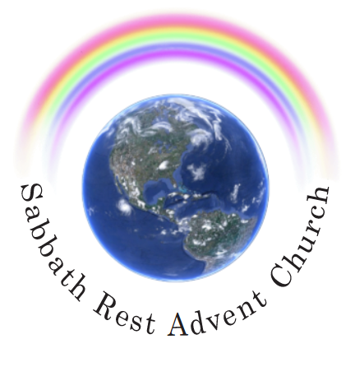

April 2024
srac.info
practicaprophetica.com

Contents
Foreword
- Did Rome Convert Britain? 1
From Apostolic Times 2
Roman Admissions 3
Testimony of Church Fathers 3
British in Early Church Councils 4
Britain’s First Martyrs 4
Visits to Holy Places 6
- Britain’s First Evangelists 8
Scattered Abroad 9
Who Were the First Evangelists? 9
Soldier Missionaries 12
Christian Colonists 13
Returned Captives Carry Gospel 13
- Persecuted Yet Triumphant 14
The First of the Martyrs 15
Constantine and the British Church 16
Early Organization 18
- How Ireland and Scotland Were Evangelized 20
How Ireland Received the Gospel 21
Conversion of Patrick 21
A True Gospel Missionary 22
Columba, the Apostle of Scotland 23
Greater than Augustine 24
- The First Clash With Rome 26
With Flame and Sword 26
Flight of British Church 27
A New Vision 27
First Conflict with Rome 28
Ascendancy of Celtic Christianity 29
- Did Rome Convert the Saxons? 30
Augustine’s Methods 31
British Church Refuses to Submit 32
An Abortive Mission 34
British Church Takes Up the Task 34
Aidan, the Apostle to England 35
- How Britain Preserved the Ancient Faith - I 37
The Bible Only 37
Columba a Bible Christian 38
What Rome Denounced as Heresy 39
A Catholic Admission 40
Early British Church Observed Seventh-Day Sabbath 41
- How Britain Preserved the Ancient Faith - II 43
Giving the Bible to the Common People 43
British Church Rejects Apocrypha 44
Preaching and Teaching 44
Absence of Ritualism 46
Apostolic Organization 47
Religious Liberty 48
- The Eclipse of the Early British Church 50
Peter’s Keys 51
Submission of the British Church 52
Enthralled but Not Absorbed 53
Dawn of the Reformation 54
Rome’s Modern Challenge 54
Afterword 56
Picture Credits 60

Foreword
I STUMBLED across these articles, in the 1932 Present Truth periodicals (a British Advent periodical), while looking for something else. They immediately caught my interest and seemed worthy of presentation in a more modern form.
These articles sketch out some details of the history of the early British church, which was apparently founded around the time of the apostles. They show how it grew up independent of Catholicism, and only later, under increasing pressure, succumbed to its influence. The existence of such a group of believers is, of course, a rebuke to the Papal claim that she is the preserver of the faith. Here was a church in existence in a purer form, from apostolic times.
Historical records, however, are scarce. Much history was destroyed by wars; much more, no doubt, by the Catholic practice of destroying the records of what they believed to be “heresy.” So we are left with sketches and fragments.
I have used equivalents for the pictures that were in the original articles, as the quality of the originals was poor. In a few instances, it is impossible to escape the “Romanization” of the figures in the pictures: the use of halos, Catholic symbolism, etc. This is because the Catholic church eventually incorporated the leaders of the British church into their own pantheon of saints, and therefore, any artwork made of them is likely to be infected with these misconceptions.
Nevertheless, and in spite of this, the thrilling history of this early church, and its missionary endeavors, holds many lessons for the church of today.
Frank Zimmerman
practicaprophetica.com
- Did Rome Convert Britain?
Is the British Church a Child of the Papacy? A Popular Fallacy
THE story is familiar to every school-child how Gregory, the Benedictine monk, passing one day from his monastery through the Roman Forum, chanced to see among the slaves exposed for sale three flaxen-haired, fair-complexioned children. Asking the Jewish dealer whence they came, he learned that they were Angles from the land of the Britanni.
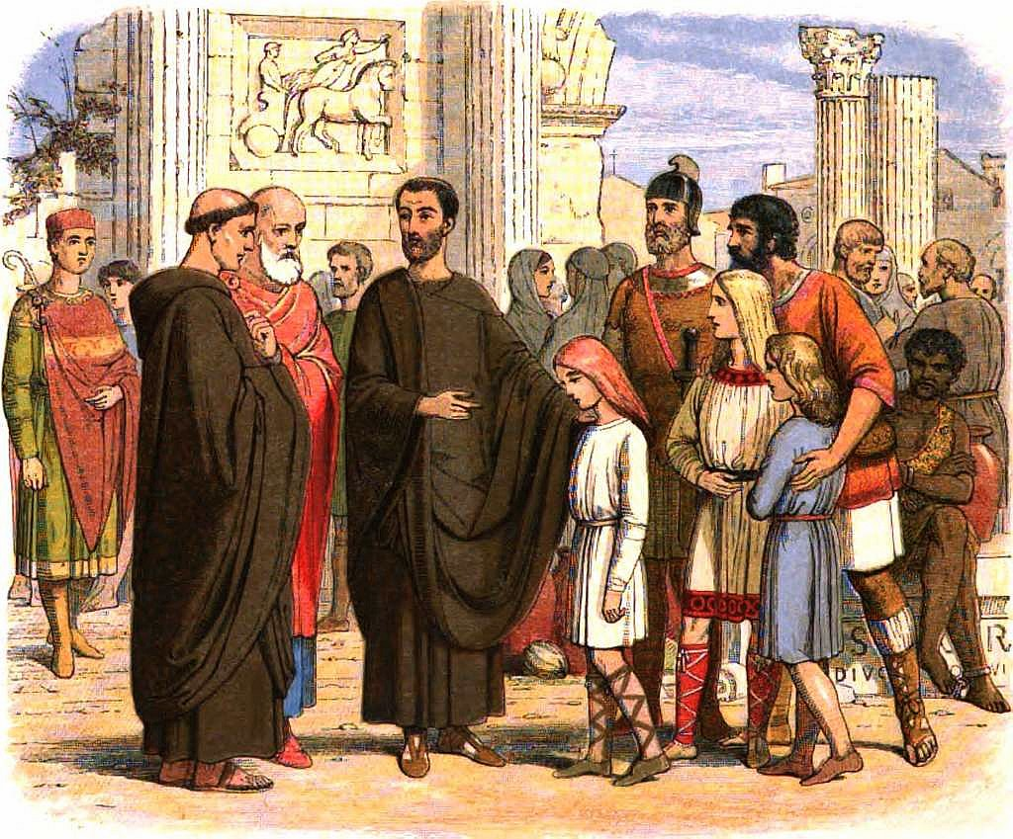Gregory sees the little English children in the slave market at Rome and plans to take the Gospel to their homeland.
“Not Angles but angels,”
–exclaimed Gregory, and forthwith proceeded to the Pope to request permission to devote his life to the evangelization of Britain.
He set out secretly on his mission with a number of companions, but when three days on his journey he was recalled and placed upon the papal throne as Gregory I. Unable then to go himself to Britain he delegated the task to Augustine, the prior of his old monastery, who landed at Thanet in Kent among the pagan Saxons in the year 590 AD.
On the grounds of this story it is sometimes asserted and quite commonly believed that the present Protestant church of Britain is a delinquent offshoot, an apostate daughter, of the Church of Rome. Nothing, however, could be farther from the truth.
Though Catholic writers by intent, and others through ignorance, seldom go back earlier than the Augustinian mission, the church in Britain actually had a history of several centuries when he arrived. In fact, hundreds of years before ever the Bishop of Rome sought to claim for himself the leadership of all the churches, and probably before there was a bishop of Rome at all, the Gospel was planted in these isles.

From Apostolic Times
Gildas, the earliest of English church historians, who lived in the first half of the sixth century, traces the roots of the British church right back to apostolic times.
We know that Christ, the true Sun, afforded His light to our island in the last year of Tiberius Caesar.
Tiberius died in March, 37 AD, so that according to Gildas Christianity must have come to Britain less than a decade after the crucifixion, and within a short time of the stoning of Stephen and the scattering of the infant church! Sir Henry Spelman in his Concilia attests this early date:
We have abundant evidence, [he says,] that this Britain of ours received the faith...soon after the crucifixion of Christ.

Roman Admissions
Nor are such assertions confined to non-Roman authorities. Polydore Vergil in tire reign of Henry VII and Cardinal Pole in the sixteenth century have both left on record that Britain was “the first of all countries” to receive the Christian faith. And Robert Parsons, a Jesuit, who wrote a book entitled, The Three Conversions of England, to prove that three times Roman missionaries had evangelized our land, admits that,
The Christian religion began in Britain within fifty years of Christ’s ascension,
–and that from a non-Roman source! When one who is seeking to magnify Rome’s part in bringing the Gospel to our land is constrained to acknowledge a fact so, antagonistic to his thesis, its veracity is abundantly authenticated.
The question of priority of churches was raised at the Roman Council of Pisa in 1417 AD, by the French and Spanish ambassadors who ventured to contest the accepted antiquity of the British church. But their protest was defeated. Not satisfied with the decision, they raised the issue again at the Council of Constance in 1419 AD, and yet again at the Council of Sena, but on each occasion their claim was set aside, it being asserted that the church in Britain was founded…
...immediately after the passion of Christ.

Testimony of Church Fathers
Among the writings of the church fathers are to be found many indications that the British church at a very early date was well known throughout the Empire.
Tertullian, for example, one of the fathers of North Africa, writing about the year 200 AD, states that Christianity was to be found even beyond the limits to which Roman arms had penetrated, including the isles of Britain. These are his words:
The extremities of Spain, the various parts of Gaul, the regions of Britain which have never been penetrated by the Roman arms, have received the religion of Christ.
Writing about a quarter of a century later we have Origen, one of the most noted teachers of Alexandria, stating that:
The divine goodness of our Lord and Saviour is equally diffused among the Britons, the Africans. and other nations of the world.

British in Early Church Councils
From the fourth century we not only have the testimonies of Eusebius, Bishop of Caesarea (320 AD), and Jerome of Jerusalem (378 AD), but also catalogs of British representatives attending the earliest of the general councils of the church. Three bishops, a presbyter, and a deacon were present in 314 AD at the Council of Arles, convened to discuss the date of Easter, the ceremony of baptism, and the mode of ordination of bishops or elders of the church.
After the Council of Nicaea (325 AD), which met to rebut the Arian heresy, Constantine the Great wrote a general letter to the churches in which he included the British bishops in the unity of the faith. Athanasius of Alexandria, corresponding some years later (363 AD) with Jovian, mentions that the British bishops “accepted and assented to the faith” as defined at that council.
Then at the Council of Sardica (modern Sofia in Bulgaria) in 344 or 347 AD, no less than thirty-three bishops from Gaul and Britain were present.

Britain’s First Martyrs
The great growth of the British church during the early centuries is further attested by the long list of martyrs to the faith in the Diocletian persecution. Although lasting for only one year in this country as against some eighteen years in other parts of the Empire, as a result of the tolerant attitude of Constantius Chlorus the governor, some thousands of souls laid down their lives. Such numbers and their distribution throughout the country most evidently indicate the existence of a very large church extending over the whole land.
During the terrible persecutions of the second and third centuries it was a common practice of the hunted Christians to use the secret sign “XP” or “Chrisma,” as it has been called, upon their meeting places and their tombs. Archaeologists have thus been enabled to identify remains bearing this monogram as antedating the Edict of Milan (313 AD), when Christianity was at last able to come out into the open.
Numerous remains of pavements, churches, and memorial stones inscribed with the “Chrisma” have been found in this country as widely separated as Cornwall, Dorset, Northamptonshire, Carnarvonshire, Wigtonshire in Scotland, and elsewhere, indicating the existence of Christians in these places prior to the beginning of the fourth century.
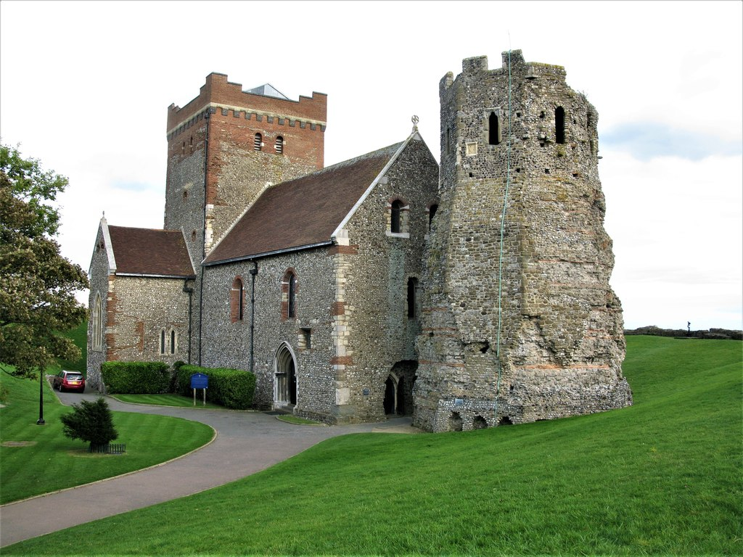St. Mary's Church in Dover Castle. The main portion of this structure dates from the fourth century—two hundred years prior to the arrival of Augustine!
In the fifth century many references were made by the fathers to the British church. Augustine of Hippo asks,
How many churches are there not erected in the British Isles which be in the ocean?
And Chrysostom, Patriarch of Constantinople in 402 AD, commends British piety in a very striking manner:
The British Isles which are beyond the sea, and which lie in the ocean, [he declares,] have received the virtue of the Word. Churches are there founded and altars erected. Though you should go to the ocean, to the British Isles, there you should hear all men everywhere discussing matters out of the Scriptures, with another voice indeed, but not another faith, in their different tongue, but the same judgment.
Another reference was made by the same author in his Homily on Luke’s Gospel to the effect that,
The power of the Saviour is felt even among those who are divided from our world, in Britain.

Visits to Holy Places
Further proof could hardly be asked for, yet one more line of evidence may be mentioned, namely, the records of pilgrimages made by British Christians to the holy places of Palestine. During the years of persecution such visits were impossible, but as soon as Constantine the Great proclaimed liberty to Christianity throughout the Empire, we find fervent British Christians undertaking the long and arduous journey to see for themselves the places made holy by the presence of their Lord.
Jerome who lived near Jerusalem in the latter half of the fourth century mentions in his letters that he frequently came into contact with British pilgrims, and Melania the Elder who died in 410 AD, refers to visitors from “Persia, and Britain, and all the isles.”
Thus while much valuable information relating to the beginnings of the British church has long since disappeared, the fragmentary information still extant abundantly testifies to the birth of Christianity in these isles at a very early date, and to the existence in the second or third, and subsequent centuries of a flourishing church distributed over the whole land.

- Britain’s First Evangelists
ALMOST the last words of Jesus to His disciples, as He bade them farewell upon the mount of Olives, were,
Mark 16
15 Go you into all the world, and preach the Gospel to every creature,
–and the infant church lost no time in applying itself to this task. Seizing the opportunity of Pentecost, when devout Jews from all parts of the Roman Empire were assembled in Jerusalem, Peter preached the first missionary sermon to representatives of at least thirteen different sections of the known world.
Acts 2
9 Parthians, and Medes, and Elamites, and the dwellers in Mesopotamia...
–from the north-east are mentioned. Arabians had come from the south-west. Asia Minor to the north was represented by Jews and proselytes from Phrygia and Pamphylia, Cappadocia, Pontus, and Asia. There were pilgrims from Crete in the Mediterranean Sea, from Libya and Egypt in North Africa, and even strangers from Rome, the center of the Empire.
Three thousands souls responded to that first appeal, and during the following days thousands more accepted the message of the Gospel. As these separated after the feast and returned to their various homes, they carried with them the good news of salvation, and began to raise up churches in the very uttermost parts of the Empire.

Scattered Abroad
Some three or four years after that eventful Pentecost, Stephen, the first martyr of the church, laid down his life for the faith, and a great persecution arose in Jerusalem. This resulted in another exodus of believers, carrying the Gospel with them into other parts.
In the 13th chapter of Acts we find that Antioch, the Graeco-Syrian capital of the East, had become a center from which evangelists were being sent forth into the regions beyond, along the great trade routes which radiated in all directions from that city. Paul, Barnabas, and John Mark received their commissions, under God, from the church at Antioch and spread the message over Asia, Greece, Macedonia, and southern Europe as far as Rome, and perhaps even farther afield.
In the second century Alexandria became another center from whence proceeded missionary pioneers into all the earth.
It is not, therefore, unreasonable to suppose that some of these fervent Christian missionaries penetrated the forests of Gaul, found themselves on the shores of the narrow channel which separated the wild islands of the Brittani from the mainland, and crossed over to carry the good news of salvation there also.

Who Were the First Evangelists?
There are many legends and traditions which suggest different leaders of the early church as the pioneers of the Gospel in Britain.
A large number of authorities declare that the apostle Paul himself visited Britain. Theodoret, for example, an ecclesiastical historian of the early fifth century, writes:
Paul, liberated from his captivity at Rome, preached the Gospel to the Britons and others in the West.
We know that Paul planned to visit Spain, and there are several years of his life between his first and second captivities of which we have no record. So that it is within the bounds of possibility that during this period the apostle did fulfill his intention to visit that country and perhaps even extended his journeyings as far as these isles. Whatever the truth may be the Rev. R. W. Morgan, author of St. Paul in Britain, says ironically that there is at least more evidence of Paul’s visit to Britain than of Peter’s ever having been in Rome!
Another group of ancient records identify the Christian worker Aristobulus, whose family is mentioned by Paul in his letter to the Romans, as one of the pioneers of the Gospel in Britain. Thus The Menologies [Martyrologies] of the Greek Church state:
Aristobulus was one of the seventy disciples, and a follower of Paul the apostle, with whom he preached the Gospel to the whole world, and ministered to him. He was chosen by Paul to be the missionary bishop to the land of Britain, inhabited by a very warlike and fierce race, by whom he was often scourged and repeatedly dragged as a criminal through their towns. Yet he converted many of them to Christianity; and after he had built churches and ordained deacons and priests for the island, he was there martyred.
Still a third group of traditions cluster round the ancient abbey of Glastonbury which, according to its earliest historian, William of Malmesbury, was founded by Joseph of Arimathea and eleven companions. The story tells that the twelve pioneers arrived in England somewhere about the middle of the first century and received, at the hands of King Arviragus, the island site now called Glastonbury, comprising twelve “ploughs” of land. Here was built a simple wattle structure, the first church building in the kingdom. From this center they preached the Gospel to the surrounding peoples and here all died and were buried. The charter of Ina says of Glastonbury:
This is the city which was the fountain and origin of Christ’s religion in Britain, built by Christ’s disciples.
It is perhaps impossible now to separate truth from fiction in the hundreds of legends and stories which have been handed down through the centuries, but the fact that they have grown up must indicate a basis of truth upon which they could be built. That basis must be that in the very earliest days of the church some of those first Christians scattered abroad turned in the direction of these isles and succeeded in planting the Gospel in the hearts of some of its then heathen inhabitants.
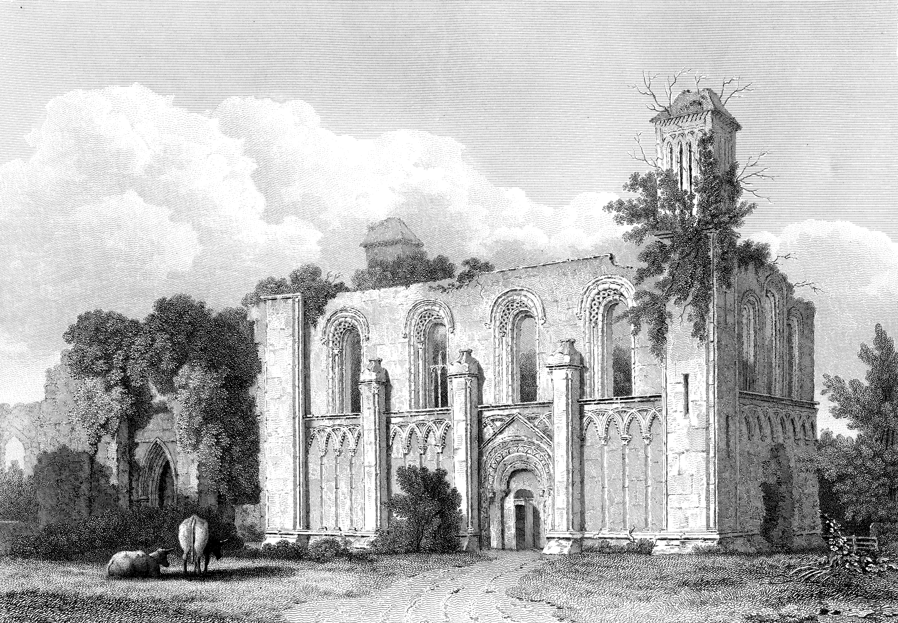St. Joseph’s Chapel, Glastonbury, said to have been founded by Joseph of Arimathea.
Robert Parsons, the Jesuit, to whose book, The Three Conversions of England, we have previously referred, is constrained to admit that:
It seems nearest the truth that the British church was originally planted by Grecian teachers such as came from the East.

Soldier Missionaries
Another avenue through which the Gospel entered Britain was undoubtedly the Roman military system. When Christianity was launched upon the world, Britain was perhaps the most talked- about country in the empire, for the simple reason that it was putting up the greatest resistance of any country to the Roman arms. Julius Caesar’s two invasions in 55 and 54 BC had carried him only as far as Verulam or St. Albans. There a treaty was concluded, the Romans evacuated the land leaving not a soldier behind, and did not set foot upon British soil for nearly a century. Thus in the middle of the first century Britain was the only independent nation in Western Europe. When, therefore, in the reign of Claudius Caesar, Rome determined to subjugate this one free race, Britain became the center of the military interests of the empire.
It would be incredible therefore if its possibilities as a mission field had not aroused noble spirits in the early church to conquer it also for the cross.
That the emissaries of the Gospel did succeed in penetrating ahead of and beyond the limits of the Roman operations is endorsed by Tertullian’s statement:
The regions of Britain which have never been penetrated by the Roman arms have received the religion of Christ.
The Roman principle of transporting the fighting men of conquered peoples to distant parts of the empire also facilitated the spread of the Gospel. British troops were deported to almost every land under Roman rule, while the troops used to garrison this country were drawn from Belgium, Gaul, Spain, Macedonia, Thrace, and many other parts. There were many Christians among these, and these soldier-missionaries stationed all over the conquered territory constituted a most important channel through which the Gospel was communicated to the native peoples.

Christian Colonists
Then there were the Roman colonists who flocked into the land in the wake of the conquering legions. London, as early as 53 AD, had over 80,000 Roman citizens, and elsewhere over Roman Britain there were other smaller settlements, each, no doubt, with its proportion of adherents of the new faith, who would seek every opportunity to spread the message of the Gospel among the natives.

Returned Captives Carry Gospel
Thousands of military captives were taken to Rome by the various Roman consuls who successively served in Britain. Most of these were ruthlessly given to the lions to provide sport on Roman holidays, or forced to kill each other in gladiatorial combat. But some were spared and came back to their native land after a longer or shorter sojourn in Rome. Might not some of these also have accepted the Gospel during their captivity, for there was a considerable church there at this time, and carried it back with them on their return?
The story is preserved that Caractacus, the noble British king who was treacherously betrayed into the hands of Rome and whose great speech before the Senate gained for him his life, was converted with his family during his seven years of “free custody” in the capital. And the church of St. Pudentiana in Rome is still pointed out as marking the site of the Gentile church established in the household of his daughter, who married a Roman senator and remained behind in Rome.
In these ways, therefore, and not primarily through the mission of Augustine and his forty companions, was the Gospel planted and established in our land.
- Persecuted Yet Triumphant
BRITAIN, of all the countries of western Europe, was least affected by the fierce persecution of the second and third centuries. While Christianity elsewhere in the empire was passing through the fires of affliction, in this country comparative peace reigned, and the church was able to multiply unhindered, until it had become almost a national institution.
The last wave of persecution, however, at the beginning of the fourth century, did break with some intensity upon British shores.
During the early years of Diocletian, Christianity had been tolerated and even honored, and it looked as if the victory over paganism was at last complete. But Galerius, his son-in-law and emperor of the East, retained a bitter hatred of the Christians, and in the nineteenth year of Diocletian’s reign, when the monarch was becoming old and enfeebled, the younger man prevailed upon him to issue an edict ordering the destruction of all Christian churches and the burning of all their religious books, as well as depriving professors of Christianity of all their rights and privileges as citizens of the empire. A second edict quickly following enjoining the immediate imprisonment of all pastors and officers of the Christian churches.
In Syria, under Galerius, the decrees were carried out with savage ferocity, as also by Maximin in Italy and Consular Africa. In the areas under the direct influence of Diocletian the persecution was comparatively mild, while in the West, Constantius, with his capital at York in Britain, was favorably disposed to the Christian faith, and probably would never himself have ordered the persecution to be carried out. Some of his prefects, however, went ahead without permission and many Christians suffered martyrdom at their hands.

The First of the Martyrs
The first and perhaps best known of British martyrs was Alban, who later became known as Saint Alban, and gave his name to the city where he died. It appears that a Christian pastor, flying for safety, was given shelter by this Alban, then a young heathen soldier of Verulam. Under the influence of the good man, Alban embraced the faith and, changing clothes with the pastor, made it possible for him to escape. Alban himself was arrested and brought before a military tribunal, before whom he nobly witnessed of his faith. He was sentenced to death and beheaded upon the slopes of the hill where now the cathedral of St. Albans stands.
After the persecution had been in progress for two years, Diocletian abdicated and Constantius was able to restrain the persecutors in Britain and Gaul, but elsewhere it continued for eight more years.
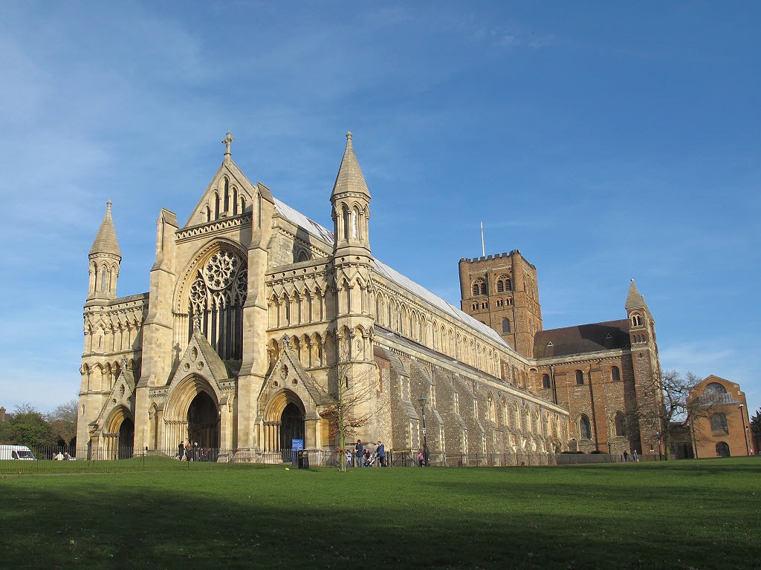St. Alban’s Cathedral, built upon the site of the martyrdom of the first English martyr.
Though in this country the period of persecution was so short, British records state that over ten thousand believers were put to death. Prominent among these martyrs were Amphibalus, bishop of Llandaff; Aaron and Julius, presbyters of Caerleon; Socrates, archbishop of York; Stephen, archbishop of London; and the bishops of Carlisle and Glasgow. These names serve to indicate how widespread and well established the British church was at this time.
The persecution under Diocletian served only to inspire the Christians of Britain to nobler activity, and as soon as freedom was again conferred upon the church, order was quickly restored throughout the land. Gildas records that:
In less than ten years of the above persecution, and when the bloody decrees began to fail in consequence of the death of their authors, all Christ’s young disciples, after so long and wintry a night, began to see the general light of heaven. They rebuilt the churches which had been leveled with the ground, they founded, erected, and finished churches to the holy martyrs, and everywhere showed their ensigns as tokens of their victory. Festivals were celebrated and saints received with clean hearts and lips, and all the sons of the church rejoiced, as it were, in the fostering bosom of a mother.

Constantine and the British Church
It is not generally realized that Constantine the Great, who established Christianity as the religion of the Roman Empire in the early fourth century, was the son of Constantius, the tolerant emperor of the West, and that he spent most of his early years in this country, under the influence of the British church.
Sozomen, the historian, in his Ecclesiastical History, states:
It is well known that the Great Constantine received his Christian education in Britain.
And Melanchthon, the companion of Luther, declares that his mother, Helen,
...was unquestionably a British princess.
On the death of his father, Constantine was proclaimed emperor of the West at York. Leaving Britain he proceeded to Italy, where he defeated the persecutor Maximin, and, in collaboration with the new emperor of the East, Licinus, issued the celebrated Edict of Milan in 313 AD. This decree gave full toleration to the Christian faith and ordered the immediate restoration of all churches confiscated or destroyed during the persecutions.
Licinus never became a Christian and on his return to the East began to persecute again. Constantine, therefore, advanced against him, and finally became sole emperor and chief patron of Christianity throughout the world in 323 AD.
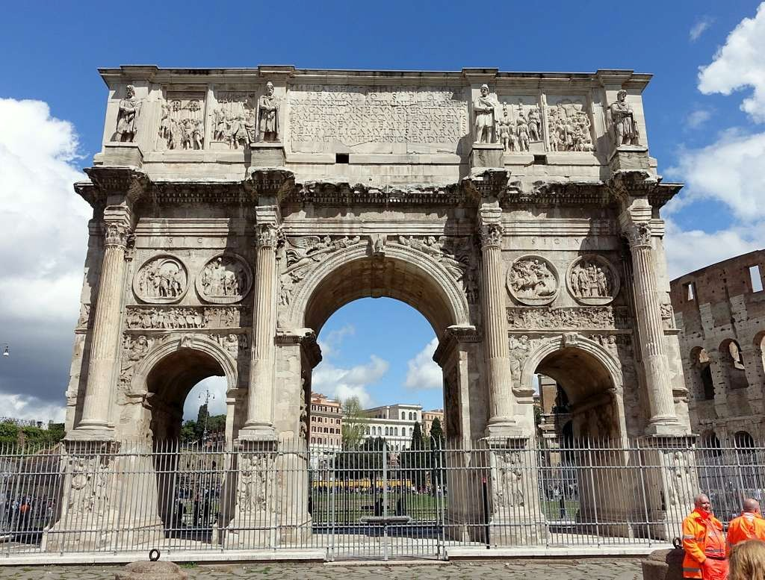The Arch of Constantine the Great in Rome. Constantine was born and educated in Christian Britain
One of his earliest decrees read as follows:
We call God to witness, the Saviour of all men, that in assuming the government we are influenced solely by these two considerations—the unity of the empire in one faith, and the restoration of peace to a world rent to pieces by the insanity of religious persecution.
Unfortunately, as with so many others in later times, his zeal for building up the Christian religion led him to pursue the same methods as the pagans had used in their opposition to Christianity, for it was he who enacted the first regulation concerning compulsory Sunday observance.
The earliest councils of the church were convened by Constantine to deal with the heresies which were arising in the church, and it was no doubt at his instigation that representatives of the British church, so familiar to him, were invited.

Early Organization
During the Roman period the church in Britain seems to have been divided into three sections, coordinating with the Roman civil provinces, each being under the oversight of a territorial bishop or archbishop. Within these areas were local bishops or “chorepiscopi,” who supervised the churches among the different tribes.
The duties of a bishop are thus described by the Leabhar Brecc:
A bishop for every chief tribe for the ordination of clerics, for consecrating of churches, for spiritual direction of princes and superiors and the ordained, for hallowing and blessing children after their baptism, for regulating the work of every church, and for encouraging boys and girls to cultivate reading and piety.
And these bishops evidently did their work well, judging by the moral stamina of the church in later times when it came into conflict with the ambassadors of the papal See.
Dotted over the country there were schools and colleges to which the youth came for education, and from which went out leaders and teachers of the church and missionaries into unoccupied areas. These schools are often described as “monasteries,” but the term is unfortunate as they bore no resemblance to the later medieval institutions of that name. Of these schools we shall have more to say later.
The picture we have of the British church in the fifth century of the Christian era is thus summarized by Gildas:
The church is spread over the nation, organized, endowed, having sacred edifices and altars, the three orders of the ministry, monastic institutions embracing people of all ranks and classes. . . . It had its own version of the Bible and its own ritual.
In the days of peace before the empire was overwhelmed by the western barbarians, the native British church, as we have seen, was in constant touch with the rest of the church, but it was not subject to any foreign jurisdiction. It did not consult Rome or any other church as to its rites, discipline, or government, nor did it seek for the consecration of its archbishops and bishops by any outside dignitary. It acknowledged no superior but God.

- How Ireland and Scotland Were Evangelized
Rome Did NOT Convert Britain
The Truth About the Beginning of Christianity in the British Isles
WHEREVER the Gospel takes root in the hearts of men there is generated the missionary spirit. Those who have tasted of the riches of divine grace glow with desire to pass on their new-found joy to others still in ignorance of it.
As soon, therefore, as Christianity became established in Britain, teachers began to go forth to those still in the darkness of heathenism. Some crossed the narrow seas which separated Britain from the mainland of Europe and took up the uncompleted work there, founding missionary churches in many of the lands whither they traveled.
As early as the end of the first century Beatus, a noble Briton, is said to have established a mission at Undersevem on Lake Thun in Switzerland and founded the Helvetian church. Early in the second century Mansuetus, also a Briton, founded the Lotharingian church in Gaul, and then pushed on into Illyria, where he was martyred. The cathedral St. Cadval at Tarentum, in Italy, is named after a British missionary who is said to have established a church there in 170 AD!
From the fifth century the British church cared for their kinsmen in Brittany, which for a long time was untouched by the Gallican church. Many of the place names there, such as St. Malo, St. Brieux, and St. Gildas, have perpetuated the memory of some of these early British missionary pioneers.
The missionaries of the British church were evidently appreciated in those early days, for many were appointed to foreign sees. The founder bishop of Treves, Marcellus, was a Briton. Cataldus became a later bishop of Tarentum. Donatus of Lupiae in South Italy and another Donatus, bishop of Fiesole in North Italy, were also of British origin.

How Ireland Received the Gospel
The most important missionary endeavors of the early British church, however, were the evangelization of Ireland and Scotland. From Britain Ireland received the faith, and then from Ireland the message of salvation penetrated to the remotest regions of Scotland and into the islands on the west and north of the mainland, until eventually the church was spread over the whole of the British Isles. The name which shines brightest among the pioneers of the Gospel in Ireland is that of Sukkat or Patrick, who later became the patron saint of Erin’s Isle.
Prior, however, to the mission of Patrick there was an abortive mission from Rome.
Coelestine, an Irishman living in Rome, brought Ireland to the notice of Coelestius, bishop of Rome, about the year 431 AD. The latter commissioned Palladius, archdeacon of St. Germain, to proceed to Ireland as its first bishop. Palladius landed in what is now County Wicklow, but opposition was so strong that he was quickly expelled. Driven out to sea he followed the British coast as far as Kincardineshire in Scotland, where he landed only to meet further persecution which culminated in his martyrdom, probably at Fordun.
One year after Palladius was driven from the Irish shores, Patrick landed in the north. Patrick was a Scottish boy, the son of a deacon and the grandson of a priest, born at Kilpatrick in Dumbartonshire somewhere about the year 395 AD. The Gospel had thus evidently already penetrated and become established at least as far north in Scotland as this place.

Conversion of Patrick
At the age of sixteen he was taken captive, together with his sister and some thousands of his countrymen, during an Irish raid, and was carried back to Antrim as a slave. For six years he toiled as a herd-boy in the service of Milchu, son of the heathen king of North Dalraida. During this long time he forgot the religion of his parents, but at last, like the prodigal son in the parable, he was brought back, in his need, to God.
He was “reformed by the Lord,” he tells us in his Confession to the Irish People, and became impressed that he was to be used of God to carry the Gospel to others who knew it not.
Soon after he succeeded in escaping from the land of his captivity and returned home to Scotland, only, however, to be captured again. He escaped again, and on reaching home the second time, there appeared to him in the night season a sound as of many voices from across the water calling:
“We beseech you, child of God, come and again walk among us.”
His friends and relatives sought to restrain him from this apparently mad enterprise, but obedient to what he regarded as a heavenly call, Patrick set off for the third time, now of his own free will, for the shores of Ireland, landing, as we have said, just one year after Palladius had been expelled from the island.
For thirty years Patrick preached Christ to the Irish people, during which time he covered the whole land from County Down in the north to Tara in the south. His first convert, Benignus, became his co-laborer, and after his death carried on the work, as Elisha took up the work of Elijah, his father in the faith.

A True Gospel Missionary
Patrick’s methods were akin to those of modern Protestantism. He preached Christ from the Scriptures with great power, pressing home conviction to individual hearts, not seeking merely the outward baptism of great masses of people which seemed to satisfy the missionaries of Rome. He preached in the language of the people, and invented an alphabet which he taught to the young that they might learn to read and understand the Word of God for themselves.
Everywhere the Gospel was favorably received he established schools, where the converts were instructed in the faith, the most promising being trained to carry the Gospel into still remoter parts.
Having spread the light of the Gospel over the whole of central and southern Ireland he completed his evangelization of the land by the conversion of Ulster and the establishment of his northern center at Druinsailech, the “hill of the willows.” Around the church which he built there grew up the city of Armagh which, sad to say, in later times was captured by the papal church and became the seat of the Roman jurisdiction in Ireland. Well would it have been if the later bishops of Armagh had followed in the illustrious steps of its founder.

Columba, the Apostle of Scotland
Among the noble young men attracted to the Gospel by the successors of Patrick and Benignus was Colum or Columba, whose father was Feidlimid, a member of a reigning family in Ireland, and his mother Eithne of Leinster, also the descendant of an illustrious provincial ruler. Born in 521 AD, he grew up amid the hills of Donegal and was sent to be educated first in the schools of Finnian of Molville and then under Finnian of Clonard, two of the most famous Christian teachers of the time. He became a deacon, and finally was ordained. At once he set out for the north, and on the shores of Loch Foyle established a “monastery” or Christian colony which grew into the city of Londonderry. Another he founded at Durrow in King’s County, and perhaps still more in other places.
The Providence which years before had sent a Scottish youth with the message of salvation to the Irish people now impressed the Irish Columba with a burden for the unentered regions of Scotland and in the year 563 AD, he set out with twelve companions to attempt this perilous enterprise.
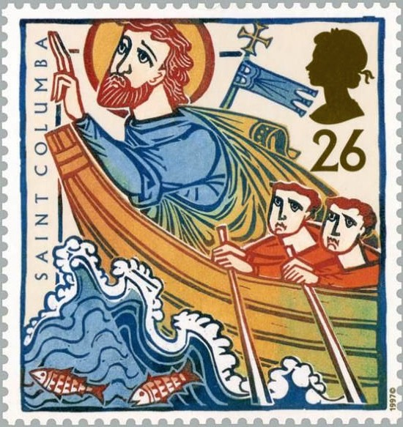
The missionaries landed at By or Iona, a rocky islet off the coast of Scotland, and established there a church and monastery. Two years later they crossed over to the Picts on the mainland. Following the lakes now forming the Caledonian Canal they reached the capital of Brude, one of the fierce northern kings, on the site of the present city of Inverness. Brude responded to the preaching of the Gospel, became a Christian, and gave his aid to their further work. By 574 AD, they had covered the whole land as far north as Buchan in Aberdeenshire and had erected churches and monasteries in many places.
In their frail coracles they sailed out to the Hebrides, the Orkney and Shetland Isles, and even as far as Iceland. Hardly a rock is to be found in all these northern seas where there are not some remains indicating the visit of one or more of these intrepid pioneers. Well says Schaff in his History of the Christian Church:
We can form no adequate conception of the self-denying zeal of these heroic missionaries of the extreme north, who, in a forbidding climate and exposed to robbers and wild beasts, devoted their lives to the conversion of savages.

Greater than Augustine
The Rev. C. Hole pays a glowing tribute to the tireless energy of Columba and his zealous companions.
Columba, [he says,] occupies in missionary history the entire generation preceding the arrival of Augustine.
Moreover, he adds,
...[he] labored much longer, in a much wider sphere, and personally with more success as well as prodigiously more romance than the first archbishop of Canterbury.
And Montalembert says of the permanence of Columba’s work at Iona:
Iona was for two centuries the nursery of bishops, the center of education, the asylum of religious knowledge, the point of union among the British Isles, the capital and metropolis of the Celtic race.
The vigorous missionary life of Columba was brought to a close on Sabbath, June 9, 597 AD. Active to the last he died, like Bede in later years, transcribing a portion of the Scriptures he loved so dearly. Reaching the tenth verse of the 34th Psalm,
Psalm 34
10 They that seek the Lord shall not want any good thing,
–he laid aside his pen saying,
“The next words, ‘Come, you children, hearken unto me,’ belong to my successor rather than to me,”
–and thereupon passed peacefully away.

- The First Clash With Rome
WITH the withdrawal of the Roman legions Britain fell upon evil days. The Picts and Scots in the north, no longer held in check, began periodically to ravage the northern part of the country. And from the East across the intervening sea came sea pirates who began systematically to plunder the towns and villages along the eastern coast.
The Britons sought to play one enemy off against the other and invited some bands of barbarian Jutes, from what is now known as Jutland, to assist them against the Picts, promising them suitable rewards when the enemy were driven back. The invitation proved fatal, for when the northern invaders had been defeated the Jutes turned their arms against the Britons themselves. After desperate fighting, the Jutes, led by Hengist and Horsa, first occupied East Kent and then obtained possession of the rest of the country. Saxon war bands followed from the German coast ravaging the southern shores, whilst tribes of Angles landed on the north side of the Thames and along the eastern coast.
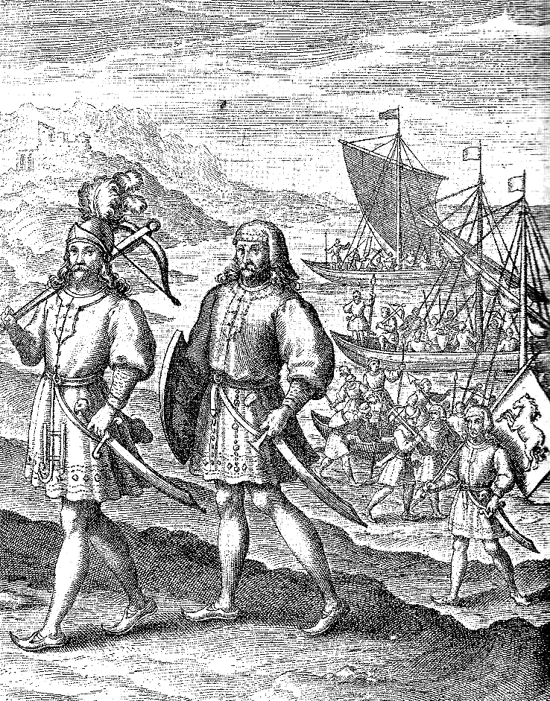Hengist and Horsa landing in Kent.

With Flame and Sword
In their progress the brutal barbarians destroyed all before them. Homestead and church were alike given to the flames, pastors and people were both slain with impunity. Gildas sadly relates that,
All the husbandmen were routed, together with their bishops, priests, and people, while the sword gleamed and the flames crackled around on all sides. Lamentable to behold, in the midst of the streets lay the tops of lofty towers tumbled to the ground, stones of high walls, holy altars.
Many of the Britons were taken captive and became slaves to the conquerors, while the rest retired westwards into the forest-guarded regions of Somerset, Devon, and Cornwall, into Wales, and northwards into Strathclyde (now Lancashire, Cumberland, Westmorland, and South Scotland). Some crossed over to Ireland and Brittany and settled there.

Flight of British Church
The three archbishops of Caerleon, London, and York remained as long as they dared, but when in 586 AD, they realized the situation to be hopeless they, too, fled with all their clergy into Wales. One hundred and eighteen bishops assembled at Llanddewi Brefi, where the church was reorganized and centers established at Bangor, St. Asaph, St. Davids, Llanbadarn, Llandaff, and Margam.
The few churches in England which escaped the Saxon torches were converted into heathen temples and their altars polluted with pagan sacrifices.
The only representatives of Christianity who remained in the country were the Christian Britons who had been enslaved.

A New Vision
The consequences of the Saxon invasion were not, however, wholly evil, for the missionary zeal of the exiled British church now restricted in the home fields was diverted towards the pagans of Central Europe who had been hardly touched by the church of Italy, absorbed as it had been in its struggle for self-preservation against the barbarian invaders of the Roman Empire.
The monastery of Iona led the way in this new field of evangelism, and for the next few centuries the Brito-Irish church became the greatest missionary force in Europe. Iona itself came to be known as the “Light of the Western World.” The first company of twelve set out under the leadership of Columbanus in 585 AD, and settled among the inhabitants of the Vosges Mountains in the south of France.

First Conflict with Rome
It was here that the British church first came into conflict with ecclesiastical Rome as distinct from the primitive and pure church established by the apostles.
In the days of Constantine, it will be remembered the British bishops had been in close touch with the rest of the church and had met with representatives of East and West in the general councils of Arles and Nicaea. Soon after this, however, the barbarians from Asia swept down upon the decadent Empire and interposed themselves like a wedge across Central Europe, thus isolating Britain from the rest of the church.
During this period, the Roman branch of the church had exalted itself largely by forged decretals and political intrigue to the position of chief of all the churches, and at the same time had become sadly corrupted through pagan influence. When Columbanus and his co-laborers appeared on the scene, most of the southern Continental churches had already submitted to the primacy of Rome.
The difference between the teachings and practices of the British missionaries and those of the new Rome, and their refusal to acknowledge the leadership of the sovereign pontiff, quickly aroused the antagonism of the Roman bishops, who organized a conspiracy to expel them. When in addition Columbanus rebuked the crimes of King Theuderick II and the queen-mother Brunhilda, which diplomacy had led the papal party to overlook, the conspirators gained the support of the court in their opposition, and Columbanus with Gall and others were compelled to move into Switzerland. There they worked successfully among the Suevi and the Alamanni. After a time they were driven from there also and took refuge in Italy, where they established the monastery of Bobbio in the Apennines. At this place Columbanus died in 615 AD.

Ascendancy of Celtic Christianity
Other companies of British missionaries carried the Gospel into Germany, Bavaria, and Thuringia, where many churches were founded. Five centers were established in the Netherlands, and others in France and elsewhere. Bernard of Clairvaux compared the Irish missionaries on the Continent to a “flood” and Aidhelm declared that they came in “fleets.” Walafrid Strabo wrote that travel had become second nature to them.
So tremendous was the impact made by the British church as it burst upon Central and Western Europe that J. R. Green says:
For a time it seemed as if the course of the world’s history was to be changed, as if the older Celtic race, that Roman and German had driven before them, had turned to the moral conquest of their conquerors, as if Celtic and not Latin Christianity was to mold the destinies of the churches of the West.
The native and independent British church is thus entitled, under God, not only to the credit for the evangelization of Ireland. Scotland, and the islands of the northern seas as far as Iceland, but also for giving the Gospel to a large part of Europe as well. Rome stepped in and usurped authority after the British missionaries had won the heathen tribes for Christ.

- Did Rome Convert the Saxons?
Facts You Should Know About the History of Christianity in Britain
IT WAS during the period of Saxon settlement and the diversion of British missionary zeal to the Continent that the ambitious bishops of the Roman church first gave serious attention to Britain.
We have already mentioned the story of Gregory and his impulse to carry the Gospel to the pagan tribes in Britain. It is very probable, however, that he was interested still more in the independent Celtic church of which he had become well acquainted. That he intended its union and subservience to the Papal See is clearly indicated in his commission to Augustine.
As to the bishops of the British Isles, [he said,] we commit them all to you, brother, that the ignorant may be taught, the weak in the faith strengthened by your word, and the disobedient corrected by your authority.
The opportunity to enter Britain came through contact with the Saxons of Kent. Ethelbert the king had married Bertha, the Christian daughter of King Charibert of the Franks. She took over to Kent with her a Christian bishop, and Ethelbert gave to them a ruined Brito-Christian church in Canterbury in which to worship. Gregory recognized in this union a lever which could profitably be used to extend his influence and entered into correspondence with the king. Ethelbert, on his part, no doubt welcomed the approaches of Gregory as a political move to reinforce and confirm his own usurpation. The outcome was the dispatch of Augustine with his forty monks and their landing in 597 AD on the Isle of Thanet at precisely the same spot where Hengist and Horsa had set their feet.
Ethelbert listened to the preaching of Augustine and on June 2nd was baptized. Soon after the Witena or parliament officially accepted the new faith, and on Christmas Day nearly ten thousand of his subjects were immersed in the Swale, two and two performing the ordinance upon each other at Augustine’s command.

Augustine’s Methods
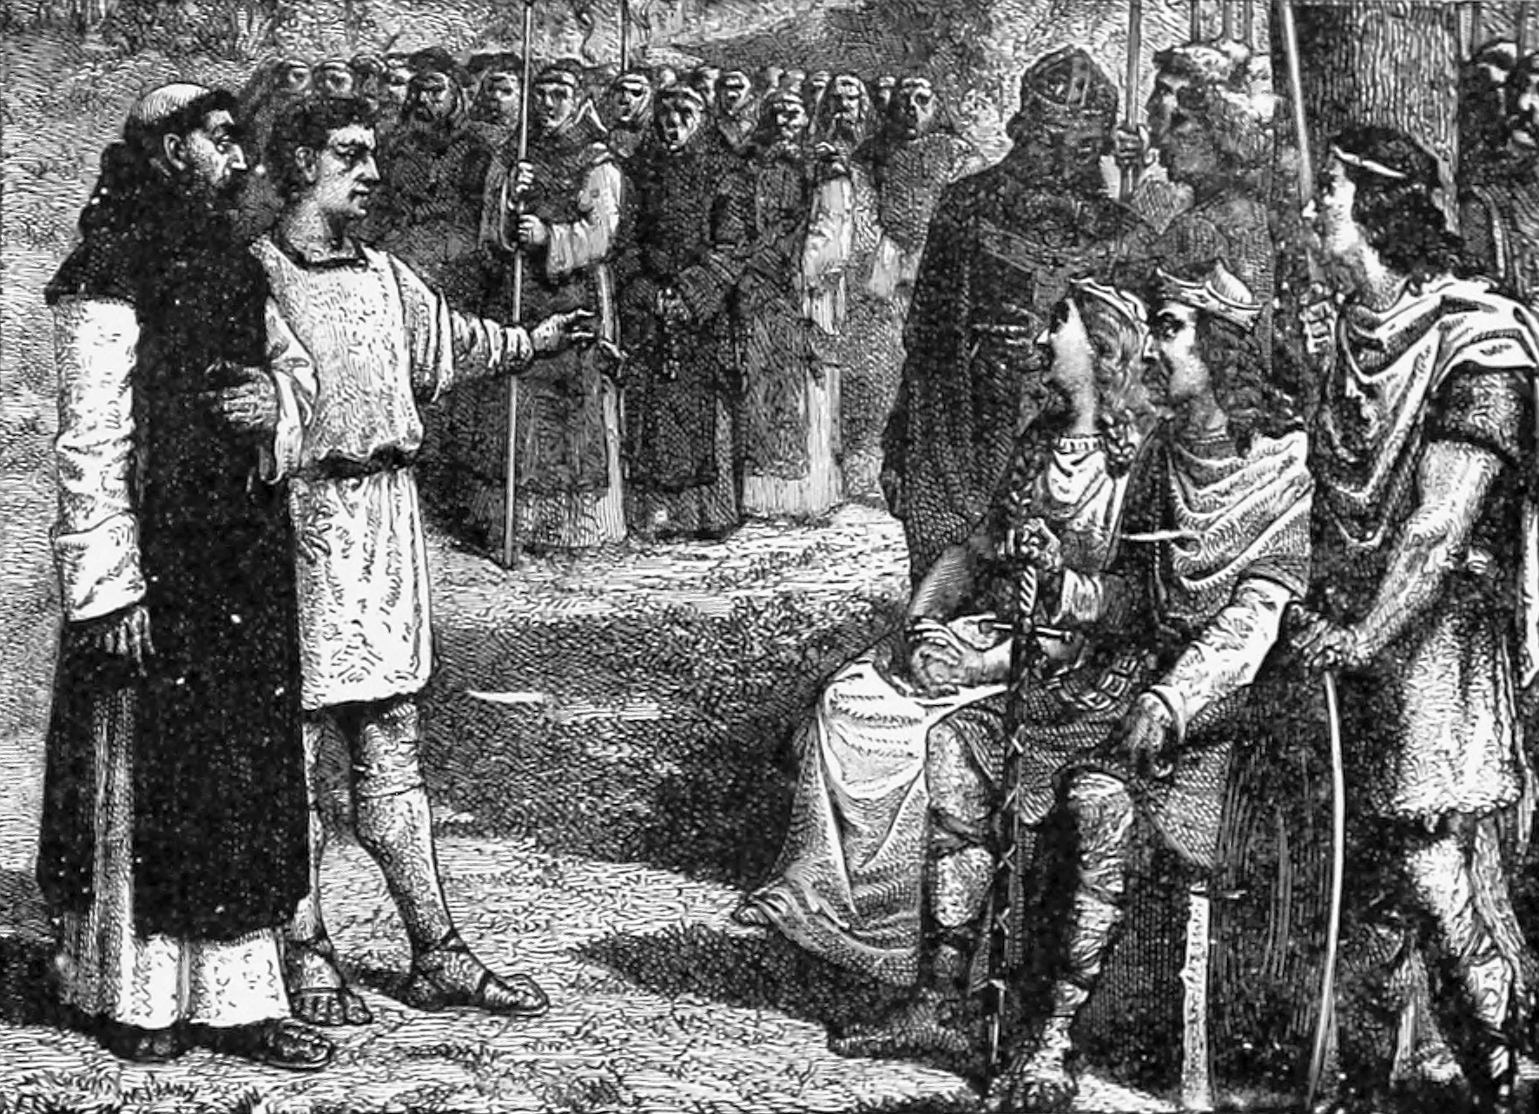Augustine meets with King Ethelbert.
The wholesale methods of Augustine are in striking contrast to the work of individual conversion carried on by the missionaries of the British church, and the Christianity he gave to the Saxons was consequently but a caricature of the true. The customs of the heathen were retained as far as possible, their significance merely being changed to Christian objects. Idol temples were purified with holy water, and dedicated as Christian churches, The heathen festivals were renamed as Christian saints’ days, and the animal sacrifices were offered as before but to the true God instead of to heathen deities.
This policy of compromise accounts for the occurrence of the names of Saxon deities in the names of the days of our week, Tuesco (Tuesday), Woden (Wednesday), Thor (Thursday), Frico (Friday), and in the names of some Christian festivals, as Eostre (Easter).
The little interest they took in instructing the Saxons in the truths of the Gospel is further shown by the fact that seventy years after the landing of Augustine, not one of the Roman missionaries could speak the native language!

British Church Refuses to Submit
As soon as Augustine had firmly established himself in Kent he set about the second phase of his mission, the subjection of the native British church. Messages were dispatched to the British bishops inviting them to meet him in conference at place in Worcester which became known in later years as Augustine’s Oak.
In 603 AD six bishops and the abbot of Bangor under the leadership of the archbishop of Caerleon, then the principal ecclesiastical authority of the native church, met him at the appointed place. Augustine laid before them his proposal that they should acknowledge the Pope as their spiritual head and submit to him as his representative in all things. The British bishops were astounded at such a haughty demand and it was met, naturally, by a very decided refusal. They stated in their reply:
“Be it known and declared that we all, individually and collectively, are in all humility prepared to defer to the Church of God and to the Bishop of Rome, and to every sincere and godly Christian, so far as to live everyone according to his degree, in perfect charity, and to assist them all by word and in deed in being the children of God. But as for any other obedience, we know of none that he whom you term the Pope, or Bishop of Bishops, can demand. The deferences we have mentioned we are ready to pay him, as to every other Christian, but in all other respects our obedience is due to the jurisdiction of the Bishop of Caerleon, who is alone, under God, our ruler to keep us right in the way of salvation.”
Augustine pressed his case with entreaties and exhortations, and then with threats, but the bishops were immovable. So Augustine lowered his demands.
“If you will obey me in these three things: in the time of observing Easter, in administering baptism according to the form of the Holy Roman Apostolic Church, and in preaching God’s Word to the English jointly with us, all your other practices we shall strive to tolerate, however contrary they be to us.”
But the British bishops, incensed by his pride and arrogant assumption, replied,
“We will do none of these things, neither will we have you for our archbishop.”
Augustine was furious.
“Since you will not have peace with brethren,” he cried, “you shall have war with enemies.”
Not long afterwards a great massacre occurred at the college of Bangor-Iscoed in North Wales, as a result of the sudden incursion of the Northumbrians under Ethelfrid. This is alleged by Bede, the English Catholic historian, to be a fulfillment of Augustine’s divinely inspired prophecy. It did not, however, induce the submission of the British church; if anything, their resistance was intensified.
Retiring to Kent, Augustine was soon superseded by Laurentius, who made another attempt to negotiate with the British and Irish bishops, but succeeded only in making the relations more bitter.
Had Gregory come over himself to England, as he had originally planned, the church might much earlier have been subdued, but it was perhaps in the providence of God that the tactless Augustine was sent, in order that the light of the Gospel should not be entirely extinguished by Rome. For the British church had yet a great work to do.

An Abortive Mission
The Roman mission had still extended no farther than Kent and after the death of Ethelbert the church began to decline even there. A revival seemed to be coming when Ethelbert’s Christian daughter married Edwin of Northumbria and with her chaplain Paulinus succeeded in winning over the Witena or parliament of Northumbria to Roman Christianity. It was, however, but short-lived, for in seeking to subdue Penda, the rebellious king of the Mercians, the champion of Christianity, was slain and paganism re-asserted itself. Paulinus fled from York. Mellitus was driven out of London and with Justus fled to Gaul, while Laurentius alone remained in Canterbury.
The Roman mission had woefully failed, and only among the people of Kent did it maintain a precarious existence.

British Church Takes Up the Task
Rome’s failure now became Britain’s opportunity. The refusal of British bishops to cooperate with the Roman mission had not been because of any neglect of mission work, for we have already seen that the propagation of the Gospel was the one great task to which the church in Britain had set itself. It was simply because they did not feel free to cooperate with a church with which they had so little in common. When, however, the emissaries of Rome left the field in despair, the British church stepped into the breach and accomplished what they had failed to do.
It happened that after the death of Ethelfrid of Northumbria, a period of turmoil followed, and the king’s sons found refuge in Iona. Oswald sincerely embraced Christianity and on the death of Edwin returned to Northumbria. Having recovered the throne, he immediately invited the Columbans to send a teacher to instruct his people in the faith. The first missionary soon became discouraged by the bigoted and intractable nature of the pagans and returned.

Aidan, the Apostle to England
The saintly Aidan was next dispatched together with a number of helpers. The mission settled in the island of Lindisfarne in 635 AD, erecting there a church and school to which the Northumbrian youth were soon attracted in large numbers. From this center the followers of Aidan went forth from village to village and from house to house between the Humber and the Forth, preaching, teaching, and establishing churches and schools on land donated to them by the good king Oswald. Even Bede, himself a Roman Catholic, admits that by Aidan and his successors…
...was all northern England recovered from paganism.
From the school at Lindisfarne missionaries also went out to other sections of England to spread the Gospel of Christ. Cedd went with three followers to Mid-Anglia, and later led a mission to the East Saxons over whom he was consecrated bishop by Finan thirty-eight years after the expulsion of the previous Roman bishop, Mellitus. Another scholar, Chad or AEadda, became the apostle to the Mercians of the Midlands, who had hitherto withstood all attempts at conversion.
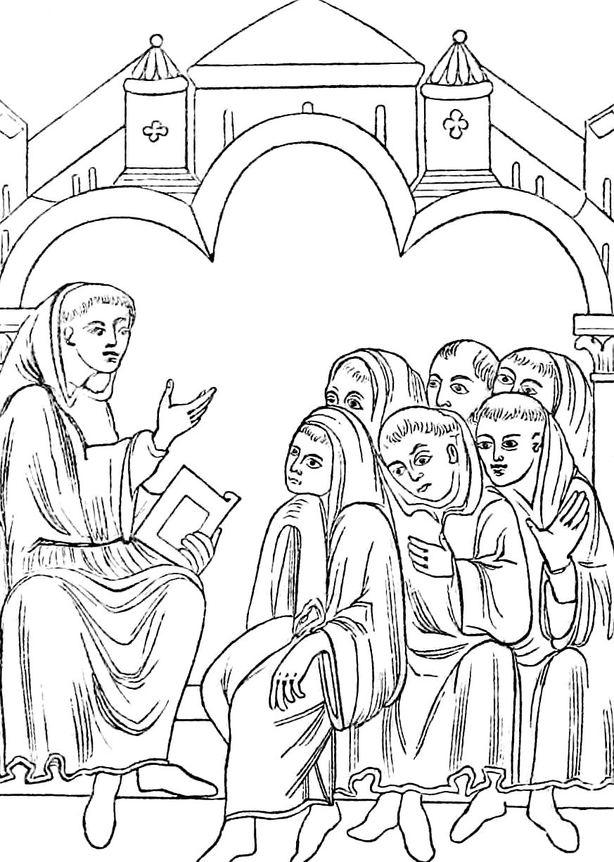Teaching at Lindisfarne.
Hilda, the grandniece of Edwin, had been baptized with him at the age of thirteen, and when Christianity was re-organized in Northumbria was instructed by Aidan. From Lindisfarne she went to Whitby, where she organized a monastery, whence there went forth the principal clergy and bishops of the province of York. She also instructed Caedmon, the first poet and paraphraser of Scripture in the Saxon tongue.
Aidan and his followers were supported in their efforts by other missionaries from Ireland. Diuma and Ceollach went to the Mercians, Fursa went to the East Anglians of Suffolk, and another Irish missionary went among the pagan South Saxons of Sussex, the last mentioned, however, not having much success.
Thus by about 660 AD the whole of Saxon England, except Sussex, had been united with the fold of Christ. But the work had been accomplished by the missionaries of the British and Irish churches and not by those of Rome. Actually outside Canterbury there was only one bishop of the Roman communion in England, namely Wina of Winchester, and he later deserted his party or was deposed.
We may, therefore, very truthfully say with Bishop Lightfoot, that,
“Not Augustine but Aidan is the true apostle of England.”

- How Britain Preserved the Ancient Faith - I
THE conflict which arose when the native British church came into contact with the Latin church of Rome on the Continent and in this country leads us to inquire in what way the two differed from each other.
We know that they disagreed as to the primacy of the Bishop of Rome. We know also that they must have differed in doctrine and practice, for the British missionaries were everywhere denounced as heretics and false teachers. But seeing that in the Roman church the accretions of heathenism and pagan philosophy had well-nigh obscured the fundamentals of the Gospel, we may well ask whether British teaching was really heretical, or whether it was not rather the ancient faith, preserved through the centuries in an out-of-the-way corner of Europe, coming into contact with the so-called Christianity of an apostate church.
Our information on this question is unfortunately very fragmentary,
- Because of the vandalism of the pagan Angles and Saxons who, as we have seen, carried fire and sword through the land, destroying everything in their path; and
- Because of the pertinacity with which the later Romish usurpers destroyed every remnant they could find of the Celtic church.
Yet in spite of all the obstacles to preservation some documents have come down to us, which indicate that the early British church did shine forth with a purity and a piety in striking contrast to the errors, the superstitions, and the idolatry of Rome.

The Bible Only
British Christianity was founded not upon the word of the priests and the writings of the Fathers, but upon the Word of the living God. We have already mentioned the statement of Chrysostom in 402 AD that,
Though you should go to the ocean, to the British Isles, there you should hear all men everywhere discoursing matters out of the Scriptures.
Patrick carried the Scriptures to the Irish people and preached Christ mightily to individual hearts. His Confession abounds in scriptural references. Some Roman Catholic authorities have claimed that he taught many of the modern doctrines of Rome, but this is contradicted by his extant writings. He everywhere appealed to Scripture as the only ground and test of Christian doctrine. Never does he refer to tradition as a source of authority.
In a hymn composed when about to appear before the chiefs of Tarah, the oldest piece of Irish literature in existence, he prays:
At Temur today may the strength of God support me, may the power of God preserve me, may the wisdom of God instruct me, may the Word of God render me eloquent.
And again:
Christ be with me, Christ before me, Christ after me, Christ in me, Christ my right, Christ my left, Christ in the heart of every one I speak to, Christ in every mouth that speaks to me, Christ in every ear that hears me.
There is no appeal to Mary, to angels, or to departed saints, but to the power of God alone.
Patrick did not teach the doctrine of purgatory which is so fundamental a part of Roman doctrine. And celibacy found no place in his gospel for, as we know, he himself was the son of a deacon and the grandson of a priest. Nor did auricular confession and papal infallibility form any part of his creed.

Columba a Bible Christian
Columba, the apostle of Scotland, was also a Bible Christian. Writing on one occasion respecting the doctrine of the trinity he laid down very definitely the principle:
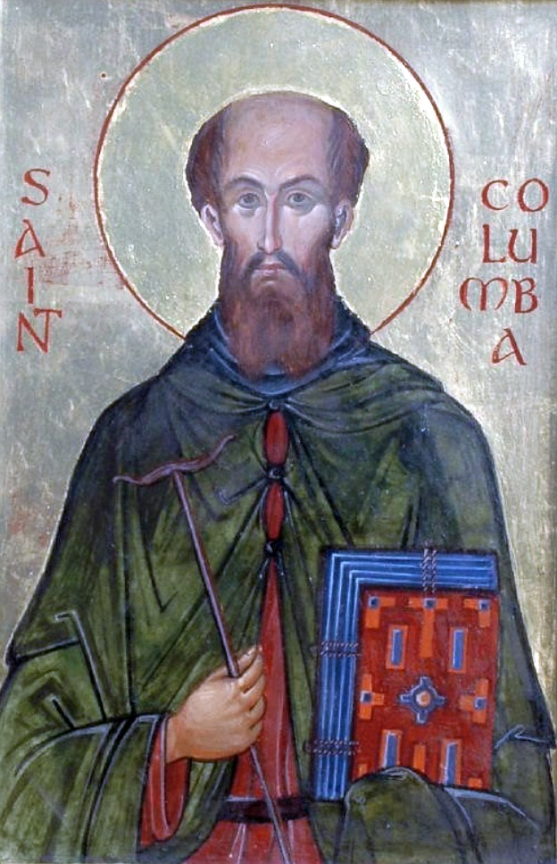
Except what has been declared by the law, the prophets, the evangelists, and apostles, a profound silence ought to be observed by all others on the subject of the trinity.
Adamnan, his ninth successor at Iona, says that his preaching and his great instrument of conversion was the Word of God. At his death, which is described in detail by Adamnan, there was no thought of extreme unction or of absolution,
...no crucifix held up to his eyes, no masses said, no fear of purgatorial fires; but on his part, perfect peace, and on theirs [his friends] resignation and thanksgiving.
Writing of the piety of the early Scottish Christians, G. Grub, in his Ecclesiastical History of Scotland, says:
The reverence in which they held the sacred volume, the attention with which they studied its pages and the diligence and fervor with which they strove to conform their lives to its precepts are well known. . . . The Bible was their daily study and constant meditation, and it was their business and delight to impart its sacred treasures to all who came to them for instruction.

What Rome Denounced as Heresy
The records we have of Roman opposition to the British missionaries in Europe testify to the biblical character of their teachings in contrast with the traditional authority of Rome.
Columbanus, the first of the pioneers who went out from Iona to spread the Gospel on the Continent, when asked who he and his companions were, replied:
We are Irish dwelling at the very ends of the earth. We be men who receive naught but the doctrine of the evangelists and apostles. The catholic faith, as it was first delivered by the successors of the holy apostles, is maintained among us with unchanged fidelity.
When taken to task by Pope Gregory for refusing to accept the authority of the church, he closed his reply with the words:
And now, if as I hear, you are prepared to give me this answer, that what is established by the authority of antiquity cannot be altered—certainly error can lay claim to antiquity, but the truth which condemns it is always of higher antiquity still.
The tradition of the church, if contrary to the teaching of the Word, commanded no respect in the mind and heart of the zealous Columbanus.
Boniface, the Roman missionary to Bavaria and Central Europe in the early eighth century, denounced the British missionaries as false prophets, seducers of the people, idolaters, and adulterers. But when the list of concrete charges against one of them, Clement the Scot, are examined they are found to be his belief in the sole authority of Scripture, the freedom of the church, and the right to marry. If these were heresy and false doctrine, what was Rome’s conception of truth?

A Catholic Admission
Bede bears testimony to the pure, spiritual character of the early British church and contrasts it with shame and reluctance with the Roman communion to which he belonged. He states that while Asia, Africa, and Europe were overrun with false doctrines, the church in Britain grew up and covered the whole nation, untrammeled for four centuries by any root of bitterness. Surely a splendid tribute to the deep and faithfully-laid foundations of the master-builders.
It may be said that Pelagius, the originator of the Pelagian controversy which raged throughout Western Europe for many centuries, was a Briton, but it should also be noted that he held no heretical views until after he had left this country. And it was because of his beautiful Christian character that his views gained such a hold. When the Pelagian heresy was brought to England it was strenuously combated by the British church.

Early British Church Observed Seventh-Day Sabbath
There are a number of evidences which indicate that the church in Britain for centuries observed the seventh-day Sabbath of the early church and not the first day of the week as enforced by Rome. The account of the death of Columba indicates that he knew and observed the true Sabbath, for among his last words to Diermit his disciple on Saturday, the ninth of June, he said:
This day is called the Sabbath, that is the day of rest, and such will it truly be to me; for it will put an end to my labors.
Andrew Lang attests the fact that the Celtic church held fast to the Sabbath of Jehovah:
They worked, [he says,] on Sunday, but kept Saturday in a sabbatical manner.
And it was not until the time of the Catholic queen, Margaret, in the eleventh century, that this practice was uprooted and the Scottish church brought into complete uniformity to Rome.
W. T. Skene finds traces in the early church of Ireland also of the observance of the seventh day as the Sabbath.
We should not, of course, form a right idea of the Christianity of Britain in these early days if we were to imagine that it was the absolutely pure and unadulterated doctrine of the apostles. Although Britain had been preserved through the years from the later grievous errors which had grown up in the Roman church it had its share of the errors which had crept into the church in the earliest days, before the barbarian invasions had isolated Britain from the rest of Christendom.
Thus they had come to regard the table of the Lord as an altar and the communion as a sacrifice in which there was inherent merit, though they had no defined doctrine concerning it, and they adhered to the biblical practice of taking both of the bread and the wine, not withholding the latter from laymen as in Roman ritual.
The pastors of the church were wrongly looked upon as priests, and they themselves adopted the unscriptural practice of shaving their heads. But this was not in the approved Roman style, as is shown by Augustine’s demand that the British bishops should modify their tonsure to conform with the requirements of the Latin church.
Yet allowing for these and other errors which had crept very early into Christian belief, the British church was free from all the ecclesiasticism of Rome and steadily adhered, as best they knew, to the principle of the Bible and the Bible only as the only source of doctrine and authority.

- How Britain Preserved the Ancient Faith - II
WE SAW in our last article how the Roman church had raised tradition to the level of, or even above, the Scriptures as a source of doctrine and authority, while the early British church still adhered to the Word of God as the full and sufficient rule of faith and life.

Giving the Bible to the Common People
A further contrast between the two churches is manifest in their respective attitudes to the dissemination of the written Word. Rome maintained its hold upon the common people by withholding the Bible from them and making them dependent entirely upon the priests for a knowledge of the way of salvation, a method which also enabled them to add to or detract from the Word without fear of contradiction.
The leaders of the British church, on the other hand, believed that the Bible should be available in the language of the people so that all might read for themselves the Word of life. As early as the fourth century, Chrysostom tells us that the British church had its own version of the Scriptures.
Unfortunately, no early British (English) Bible manuscript seems to have come down to us on account of the devastating thoroughness of the Anglo- Saxon ravages, and only a few examples of British work in Wales are known. The Irish scribes, however, were not subjected to such ruthless persecution, and a number of their manuscripts have been preserved. Many are written with beautiful regularity, and with decorative features of a most elaborate kind, which must have necessitated months or even years of work.
An early Irish version is seen in the Dommach-Avigid in the Royal Irish Academy. It is quoted in the writings of Fastidius and Patrick of the fifth century and in those of Cummianus and Adamnan of the seventh. Apparently it continued in use as late as the ninth century, for the quotations of Nennius and Asser about that time also correspond with it.
A fifth-century translation of the gospels is to be found in the Trinity College Library, Dublin. There is also there a copy of the Book of Durrow, dating from the seventh century, and said to be the work of Columba.
Columba was perhaps the greatest of the scribes of the early Irish church and was engaged in preparing a copy of the psalter at the time of his death. Baithene, his successor, completed this copy and is also credited with producing one in which the only fault was the omission of a dot over an “I”!
The Irish Bible scribes were held in very high regard and injury to them was punished most severely.

British Church Rejects Apocrypha
The basis of the first British and Irish versions was the Old Latin Bible of the Western world, but many of the British scholars so mastered the Greek, and even the Hebrew, language that they were able to correct the Latin version from manuscripts in the original tongues. And what is even more significant, they omitted from their vernacular Bibles the spurious apocryphal books of the Old Latin version which had been accepted by the Roman church!
Not only did the scribes of the Brito-Irish church zealously copy the Word of God in the language of the people, but they studied and expounded it to the people with equal diligence.

Preaching and Teaching
Wherever a monastery or Christian colony was established, a teaching staff was installed and students were attracted in great numbers. At Bangor-Iscoed in North Wales there were regularly over two thousand students.
With the destruction of the British schools by the Saxon invaders those of Ireland came into prominence and for centuries were famous throughout the whole of Europe. The names given to Ireland, “the Isle of Saints” and “the University of the West,” testify to the piety and learning of its inhabitants.
At Cuana’s monastery there were over 1,700 pupils and Las- rain had more than 1,500. Clonard in County Meath at the beginning of the sixth century was one of the most famous educational centers of the period, the usual number of pupils being about 3,000. Manual labor, devotional exercises, study of languages including Hebrew, Greek, and Latin, science, the Scriptures, and ecclesiastical literature, comprised the curriculum. On one occasion Senach tells that he was sent by Finian to see how the pupils were engaged. He came back with the word that:
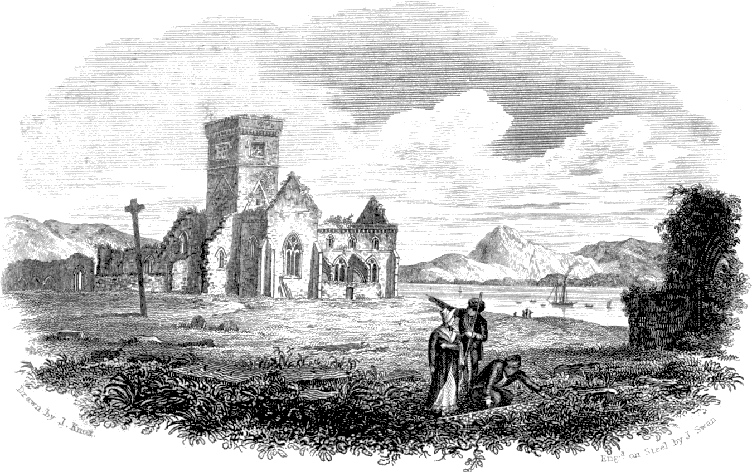Ruins of the Christian colony at Iona which for two centuries
was the center of education in Western Europe.
...some are employed in manual labor, some are studying the Scriptures, and others, especially Columba of Tirs-da-Glas, are engaged in prayer.
So great did the reputation of the Irish schools become that in later years even the French resorted thither. Dagobert II of France received his education at Slane in County Meath and the French bishop, Agilbert, also resided for a considerable time in Ireland to study the Scriptures. Kings Aidfrith and Oswy of Northumbria as well as bishops Egbert, Ethelbuin, Chad, and Willibrord were all educated in Ireland.
Bede tells us that many of the converted Saxons resorted thither:
Either for the sake of sacred studies, or a more ascetic life; some of them devoted themselves to a monastic life, others chose rather to apply themselves to study, going from one master’s cell to another. The Scots [Irish] willingly received them all, and took care to supply them with daily food without cost, as also to furnish them with books for their studies, and teaching them free of charge.
An extensive literature was produced by the learned Brito-Irish church, which, however, has now all but disappeared. One Irish teacher of the seventh century, named Augustine, is notable for the production of two treatises, one on Wonders of Scripture and another on Difficulties of Scripture, which gave evidence of such learning and wisdom that they were attributed to the pen of the great Augustine of Hippo. The canon he accepted was the same as our Protestant canon and not that of the Latin church.

Absence of Ritualism
The forms of worship among the early British Christians were simple, and corresponded with those of the church of the second, third, and early fourth centuries, during which period British bishops had been represented on the early church councils on faith and order. They knew nothing of the elaborate ritualism and the changes which had been introduced in later centuries by Rome. When the British and Roman churches came into contact during the sixth and seventh centuries the former church was still computing the date of Easter after the fashion of the early church, and still using the ceremony of single baptism by immersion in the name of the triune God instead of the threefold immersion practiced by Rome.

Apostolic Organization
In organization, too, the British church corresponded closely with the apostolic and early church. Each tribe had its own church in the charge of a bishop or elder. These local churches were self-governing, yet in brotherly contact with those in other districts. The leaders of the larger or older established churches were looked to with respect for counsel and guidance, but not as having any intrinsically higher authority. The ecclesiastical organization of the Latin church was entirely absent.
Scattered over the country were numerous centers or “monasteries” to which we have previously referred. These must not, however, be confused with the institutions of the same name which grew up in medieval times, from which they were entirely different both in purpose and conduct.
The Latin principle was isolation and separation from the world, primarily for safety and for spiritual development, and only secondarily for the good of others. The British monastery was in no way a place of isolation, but was essentially a missionary and educational center for the tribe, with church, school, and houses in which the missionaries lived with their families.
The occupants were not bound by the Roman ordinance of celibacy and were free to come and go as they chose. Patrick, the apostle of Ireland, as we have noted, was the son of a deacon and the grandson of a priest. They sustained themselves from the products of the land which they tilled around the monastery and spent the rest of their time teaching those who came for instruction, and preaching the Gospel among the surrounding peoples.
When pioneering into new places a group of missionaries secured a small portion of land within the territory of the tribe they desired to reach and there established one of these Christian colonies. Living a life of purity, holiness, and self-denial before the surrounding pagans, and practicing charity and benevolence where opportunity occurred, they won their respect. Then they went forth among them preaching the doctrines and the pure morality of the Gospel and drawing the youth to the monastery for religious and cultural instruction. When the monastery was fully established it would send out groups to other places, where a similar work was begun.
Thus the British monasteries were not like the unscriptural places of seclusion of later times, but were centers of Christian influence like the mission stations in heathen lands today.
In later times the idea of seclusion did develop, and as Romish influence gained power the monasteries were modified after the Latin type until eventually they became entirely Romanized. But it was centuries before the rule of celibacy was completely enforced.

Religious Liberty
As indicated by their church organization the British church believed in liberty of conscience and was bound together not by the bonds of ecclesiastical authority but by the ties of Christian love and a common faith.
This liberty they exemplified in their relations with all men. In their missionary activities they did not, like Rome, seek to coerce men to accept the Gospel but drew them by the constraining power of love. And they worked for men as individuals, not gathering them into the church en masse.
Without doubt the Emperor Constantine the Great in his early life had become imbued with the spirit of liberty which characterized the British church, for we find that his first religious decree, the Edict of Milan, was a model of Christian freedom:
We grant, [it stated,] both to the Christians and to all men, free liberty to follow the religion which each man has chosen.
It is sad to note, however, that he did not hold to this principle in subsequent years of his life.
When the emissaries of Rome approached the leaders of the British church to compel them to accept the primacy of the Pope, it was only natural that they should offer a most strenuous resistance. For not only were the doctrines and practices of Latin Christianity foreign to them, but the methods of Rome were the very antithesis of their conception of the church of God.
As Cadvan, prince of Wales, said to the abbot of Bangor, in discussing the British position:
All men may hold the same truths, yet no man thereby be drawn into slavery to another. If the Cymry believed all that Rome believes, that would be as strong reason for Rome obeying us as for us to obey Rome. It suffices for us that we obey the truth. If other men obey the truth, are they therefore to become subject to us? Then were the truth of Christ made slavery unto men and not freedom.
Better would it have been for England had the simple faith of the early British church lived on. But its very simplicity and its abhorrence of coercion and force made it no match for the highly-developed, complex, and powerful organization of Rome, with the result that during the centuries which followed the landing of Augustine the native church fought a heroic but steadily losing battle against the usurper, until at last the primitive church had been entirely superseded by the ecclesiastical system of Rome.

- The Eclipse of the Early British Church
SIXTY or seventy years after the landing of Augustine the Roman mission was still confined within the narrow limits of Kent. For a short time they had gained a slight hold in Yorkshire and perhaps in one or two other places, but these were very soon lost. The British church, which was to have been brought into submission to the papal See, was still independent and had actually effected the evangelization of the Angles and Saxons, where the Latin church had so signally failed.
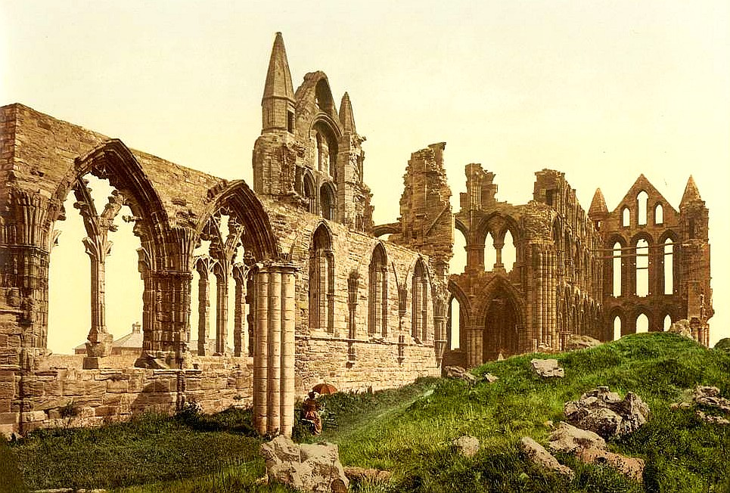Ruins of Whitby Abbey where the fateful conference was held which resulted in the eclipse of the early British church and the triumph of Rome.
But Rome was not beaten. She would await her opportunity; sometime and somehow the independence of the British church would be broken, and these isles would be brought to the feet of the sovereign pontiff.
At last the tide began to turn. Oswy succeeded his brother, Oswald, in the north and extended his rule over the whole of Northumbria and Mercia, thus becoming by far the most powerful king in the land. He married a Kentish princess, Eanflede, who brought with her to York a Romish priest, Romanus. Together they succeeded in winning over an ambitious young nobleman of the Northumbrian court, Wilfrid by name, who visited Rome and became imbued with ideas of Roman supremacy. Returning he was given charge of the young prince Alcfrid, whom he subverted from loyalty to the British church. Through Alcfrid, Oswy was persuaded to convene a conference at the great monastery of Whitby to give consideration to the case for Roman primacy. Bishop Colman appeared on behalf of the native church and Wilfrid took the side of Rome.

Peter’s Keys
Subtly Wilfrid presented his case, asserting that Peter, the head of the Roman church, had been given the keys of the kingdom by Christ himself, and therefore was able to open or close heaven to whom he would. Colman could produce no such tangible evidence of authority, and Oswy, swayed by the fallacious plausibility of Wilfrid’s argument, decided to throw in his lot on the side of the church of Peter, lest, he said,
“When I shall appear at the gate of heaven, peradventure there may be no one to open to me.”
But it was not a complete victory for Wilfrid, for the king could not escape from his lingering respect for the old church. Colman was assured that the monastery of Lindisfarne would be in no way interfered with and would be free to continue independent of Rome.
Oswy’s fateful decision, however, set the Roman party upon the first rung of the ladder to supremacy.
A few years later Theodore of Tarsus was consecrated Archbishop of Canterbury by Pope Vitalian, and arrived in England to take over the leadership of the Roman party. A diplomatist to the core Theodore realized that a frontal attack upon the native church would be futile. Victory would be possible only by subtle allurement and intrigue. So he set to work to beguile the English people by emotional appeal. Beautiful churches were built with the aid of Wilfrid at York, Ripon, and Hexham, the magnificence of which completely eclipsed the simple structures of the British church. Vestments, holy vessels, and pictures were brought over from Rome, and a special teacher arrived to instruct the choirs in chanting. Educational establishments were also settled at Canterbury and Jarrow to disseminate Roman influence and to counteract the work of Lindisfarne, Iona, and the Irish schools.
Controversy over points of doctrine and ritual were carefully avoided and everything possible was done to lessen the gap which separated the British bishops from the followers of Rome. Some who were willing to receive reconsecration from Theodore were accepted as regular priests of Rome without complete renunciation of British practices.

Submission of the British Church
When the church had been thoroughly leavened a pan-Anglican synod was convened in 673 AD at Hertford in the interests of “peace and amity.” Still not a word was said about Rome, nor about the Pope. Only unity with the “Catholic Church” was stressed, and the teachings of the "Fathers” held up for reverent acquiescence. All unconsciously the assembled bishops assented to the proposals Theodore made. The remnants of opposition of the native group were dispelled by his silver-tongued eloquence, and practically the whole church surrendered to him as its head.
Thus was the die cast, and the church unwittingly gave itself body and soul into the hands of Rome. How differently might the assembled British bishops have acted could they have foreseen the dire consequences of their action.
Under Theodore the now united Anglo-Saxon church was thoroughly organized and the country divided into dioceses with Canterbury as the seat of the archbishopric.
The years which followed were marked by further vicissitudes for the Roman church, and at one time another Celtic revival appeared imminent. Romish influences were now, however, too deeply rooted to be overthrown.
Adamnan, the abbot of Iona, submitted to re-ordination during a visit to Northumbria but was deposed by his fellow-monks. Early in the eighth century the monastery was split into two rival parties, Roman and British, rival abbots holding sway until 772 AD when the whole monastery finally conformed. Somerset and Devon maintained their independence until early in the eighth century. North Wales followed in 768 AD, and South Wales in 777 AD. The Cornish bishops held out until well on into the tenth century. In parts of Scotland Celtic practices persisted until the eleventh century when they were finally suppressed by Margaret, the wife of King Malcolm. And some parts of Ireland were not completely subjugated until well on into the twelfth century.
Well says Bacon in his Government of England:
The Britons told Augustine they would not be subject to him, nor let him pervert the ancient laws of their church. This was their resolution, and they were as good as their word, for they maintained the liberty of their church five hundred years after his time, and were the last of all the churches of Europe that gave up their power to the Roman Beast.

Enthralled but Not Absorbed
For the next few centuries Rome maintained a precarious hold upon the English church, but her sway was ever foreign to the feelings of the people. In the words of one commentator on this period:
The church was...not absorbed, but enthralled, never a part of the church of Rome, but under her sway; ever restive under her exactions and never satisfied with a usurpation which had been gained chiefly by diplomacy, false decretals, and superior craft.
Archbishop Dunstan in 970 AD refused to recognize the Pope’s interference in the affairs of the English church and Robert, the Norman archbishop of Canterbury in 1052, together with Ulf, another Norman bishop, were deposed for attempting to Romanize the church.
The year 1066 brought the Norman conquest, entered upon by William of Normandy, at the instigation of the Pope, to complete the subjection of the independent British spirit. A Norman archbishop and Norman bishops were installed and Roman discipline and order were rigidly enforced.
Gradually, however, the Normans seemed to catch the spirit of the conquered race and themselves became impatient of the intrusions of Rome. A new conflict thus developed between the Norman church and the papal See, which continued with varying fortunes for several centuries.

Dawn of the Reformation
Towards the close of the fourteenth century a great impetus was given to the anti-Roman movement by John Wycliffe of Oxford, the “Morning Star of the Reformation,” and his Lollard successors. A Roman counter-movement followed, and so the struggle went on until the reign of Henry VIII, when the fetters of Rome were finally broken and the last church to accept the Roman yoke took the lead as the first to throw it off.
During the centuries which followed, Britain became the greatest protagonist of Reformation principles and the very keystone of the Protestant church. In the nineteenth and twentieth centuries the British church has led the way in giving the Gospel to the heathen world.

Rome’s Modern Challenge
But the divine admonition,
1 Corinthians 10
12 Let him that stands take heed lest he fall,
–was never more timely than to Protestantism today. For once more Rome is in hopes of bringing Britain to her feet, and that by the same methods whereby the British church of the sixth century was enslaved.
There are many Theodores in the land again who by the subtleties of ritualism, are subverting the faith of many from the spiritual essentials of true worship. Anglo-Catholicism in the Anglican church and Free Catholicism among the nonconformist bodies both strenuously assert their independence of Rome, yet both are leading the British people back again along that same fatal path.
And there are Wilfrids, too, who are only waiting the opportunity to press openly for reunion with the church of the seven hills.
The present situation thus brings to all true Protestants a mighty challenge. We must be up and doing or our precious heritage of truth and freedom will again be wrested out of our hands.
The heavenly warning rings out to all in this hour of crisis:
Revelation 3
11 Hold fast that you have, that no man take your crown.

Afterword
By Frank Zimmerman
TIME magazine, in the issue of Monday, February 3, 1947, published an article titled, “Religion: A Light at Iona.” The first few paragraphs are as follows:
From Ireland in his little coracle the missionary-saint, Columba, sailed to the isle of Iona in the Inner Hebrides, off Scotland’s west coast. There, in 563 AD, on Iona’s misty, rainy four square miles, he established a base in the great Celtic Christianizing that swept eastward from Ireland to Britain, across to the Continent—and as far south as Vienna.
Iona became holy ground and the burial place of kings. Says Historian A. J. Toynbee:
“Had it not been for one of history’s incalculable shifts, Iona, instead of Rome, might have been the Christian capital of western Europe.”
In the 13th century, Benedictines began to build an abbey on Iona. Before he died, St. Columba had made a prophecy:
In lona of my heart, Iona of my love,
Instead of monks’ voices shall be lowing of cattle,
But ere the world come to an end,
Iona shall be as it was.
The article goes on to cover a rebuilding project that took place in the 1940’s and 50’s, in which the ruins at Iona were replaced with a new Abbey and religious center. This was assumed to be the beginning of the fulfillment of Columba’s prophecy.
However, assuming the prophecy to be a true one, and that its stipulation was “Iona shall be as it was,” it is important to determine exactly what Iona was, so we can determine what the fulfillment will look like.
According to the historical information given in this book, Iona was a missionary center, from whence the light of the Gospel flowed out, and spread into the Ireland and the British Isles, and further into western Europe. It was a microcosm of what the earthly Jerusalem should have been, but rarely was.
This brings us to the other part of the prophecy, which is, “What is an Iona?” I might extend this question to other Biblical vessels:
What is an Israelite?
What is a Jerusalem?
What is the Temple of God?
On all these questions, men have continually stumbled, because they put their faith in the vessel that God used, and not in the God who was working through the vessel. The vessel can change, but God remains the same. Let’s take the first question,
“What is an Israelite?”
How did Jesus answer that question?
John 1
47 Jesus saw Nathanael coming to Him, and said of him, Behold an Israelite indeed, in whom is no guile!
If you asked men, “What is an Israelite?” most of them would reply, “One born of a certain bloodline.” But Jesus looked to the inner character. When He saw the honesty of Nathanael, He identified Him as an Israelite.
The very term “Israel” comes from the struggle that Jacob went through with the Angel. He had gone off into solitude to pray for God’s protection, as he was soon to meet his brother Esau, whom he had defrauded of the birthright blessing many years ago. He wanted to be sure that God was with him.
As he prayed, a stranger suddenly touched him and they wrestled against each other through the night hours. Finally, as the dawn began to break, the stranger touched Jacob’s thigh and he was instantly crippled. He understood that the antagonist was a divine messenger, and realized he had been fighting against God. The very fact that his impulse to defend himself came out that night, showed that his trust in God was faulty. He saw his weakness, confessed it, and clung to the Angel for the blessing of forgiveness. It was granted, and his name was changed from Jacob (a usurper) to Israel (a prince of God, or one who prevails with God).
Through relying on the power of God, Jacob overcame himself. And that is what a real Israelite is: one who takes hold of the power of God, and overcomes his own weaknesses, especially his disposition to trust in human strength and ingenuity, instead of relying fully on God’s wisdom and power.
What is an Iona? Iona was a missionary center, teaching missionaries and sending them out to present the Gospel truth. At the same time, the false church was extending its power through the world and dominating the faith of the people. Iona was a center of light for God’s truth, in an age of growing darkness.
In prophecy, we understand that in the last days, there will again be a false religious power, extending its dominion over the whole world. It is labelled “Babylon the Great,” but we must not look to geographical Babylon to find it. The Babylon of the Old Testament was a world-ruling kingdom that contained a certain character and philosophy. The vessel that contained that character was the outward kingdom and its geographical location. That kingdom has since passed away. Today, we identify Babylon by looking for the same character and philosophy. The location may change, but the character stays the same.
Likewise with Iona. If it is to “be as it was,” then we must look for centers of light and truth, sending out missionary workers, at a time in which apostasy in religion is growing in strength and power, and spreading its darkness over the world. The Iona’s of today will be centers that produce God’s champions to battle this spiritual darkness.
While it is possible that the geographical location of the historic Iona might become a center for light and truth again, man’s disposition to exalt the vessel usually makes this impossible. The vessel often needs to be changed, in order to show man that it is not the vessel but the treasure that is important. When men focus too much on the vessel, as if there were some magical qualities associated with it, then God changes the vessel to something more humble, so that the glory may be of Him, and not of man.
2 Corinthians 4
7 But we have this treasure in earthen vessels, that the excellency of the power may be of God, and not of us.
We can therefore say with Columba, “Iona will indeed be as it was,” but where that Iona will be located, we cannot say. May there be many of them, and may the Columba’s of our day step forward and fill their God-ordained place!

Picture Credits
Chapter 1
Gregory and the English Slaves: picryl.com; taken from A Chronicle of England, James Doyle 1864.
St. Mary’s Church: geograph.org.uk; photographer: G Laird.
Chapter 2
St. Joseph’s Chapel: Alwyn Ladell, flickr.com; photo of old engraving: Glastonbury Monastery, Chapel of St. Joseph of Arimathea, c.1815. Drawn by Charles Wild (1781-1835) and engraved by C. Heath.
Chapter 3
St. Alban’s Cathedral: geograph.org.uk, picture #: 3880649.
Arch of Constantine: timelessmoon.getarchive.net; picture #: dsc01388.
Chapter 4
Columba on a Missionary Voyage: UK Stamp: Missions of Faith—St. Columba in Boat, 1997.
Chapter 5
Hengist and Horsa: wikimedia; original caption: “The Arrival of the First Ancestors of Englishmen out of Germany into Britain,” from A Restitution of Decayed Intelligence by Richard Verstegan (1605); artist: Richard Rowlands.
Chapter 6
Augustine meeting Ethelbert: Bible Brilliants, 1889.
Teaching at Lindisfarne: Saint Cuthbert by James Raine, 1828.
Chapter 7
Columba with the Bible: Jim Forest, flickr.com; iconographer: Aidan Hart.
Ornament with open Bible: Bible Handbook, 1883.
Chapter 8
Ruins of Iona: The Life of St. Columba, 1824.
Chapter 9
Ruins of Whitby Abbey: jenikirbyhistory.getarchive.net, Flickr Commons Project, 2015

Ecclesiastical History.
Dei Fidei, page 179.
On Psalm 149.
Works, Paris Ed., page 676.
Acts 2:9-11.
Acts 2:41.
Acts 2:47.
Acts chapter 7.
Acts 8:1-4.
Romans 15:24.
Romans 16:10.
Vol. 1, page 15.
Dei Fidei, page 179.
Ecclesiastical History, 1, 8.
Book 1, c. 5.
Epistles, page 187.
Medieval Christianity, 1, 67, sec. 18.
Short History of the Christian Church, page 86.
Hengwrt MSS., Cottonian Library (British Museum).
Lib. iii.
Butler’s Lives of the Saints, Article: “St. Columba.”
History of Scotland, I, 96.
Ecclesiastical History, Book 3, sec. 27.
Modern Romanism Examined, page 388.
https://content.time.com/time/subscriber/article/0,33009,886337-1,00.html.
See Genesis chapter 32.

